General Notes
- Power analysis
- Initial data analysis folder containing summary statistics and charts
- Include stats on graphs (shorthand ‘***’)
- Create project worklog that has step-by-step, exact actions (numbered), including ‘launch investigation i_00x’ and keep on top level of directory
- The readme should be the project overview. Update this at the end of every week (this will help consolidation of information and review to catch problems). This should be written so anyone that looks at it could understand and take over the project.
- This is a good example of how to write a professional python script (note __main__ usage at bottom) this was the phylogeny python script from L4141 coursework
https://github.com/edgardomortiz/vcf2phylip/blob/master/vcf2phylip.py
- Using dplyr::select() might be better for reproducibility than just select().
  - I’ve had issues when using select() with deseq2 due to a conflict with deseq2-associated packages. Using the :: will make it reproducible in case someone else has conflicting packages loaded or they update packages which will then cause conflict. Do this for all commands like this – seen it in other githubs
- Need to perform stats on the overlap between my results and the company’s results for Part 1 of the project
- Company that performed the bioinformatics analysis for them = tamiRNA https://www.tamirna.com/
  - The website has example papers that it has been involved in – can use these as inspiration
- see l4137 example github from previous year https://github.com/adharafardhin/LIFE4137/tree/main
- 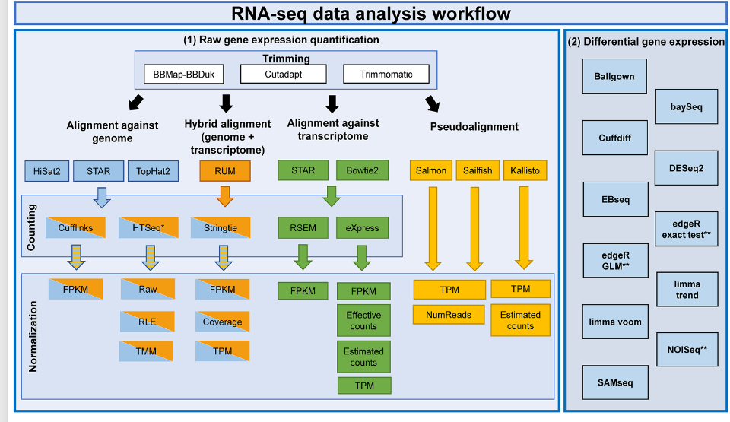
- If there’s time AND my results align with the tamiRNA results, can look at making a simple web app that takes the data in then you can select what you want to do with it and it will output the deseq2 results/graphs
  - This is supposed to be something that can be performed by wet scientist (as Lucy and Georgina tried it but couldn’t do it – this would be something to bridge the gap)
  - Could create a parallel report at the end (similar to the quast reports) that compares the results from multiple tests with different parameters e.g. different samples excluded based on quality
  - Simple guides/help buttons at each step to indicate to reader how to make decision (can just be placeholder, e.g. state what the button will do, if not finished in time)
- 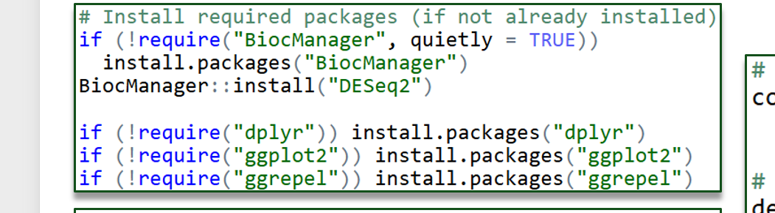 for R package installations (taken from transcriptomics lecture)
- Normalisation method is discussion point

PART 1 – DGEA
- Need to be confident with the annotation for miRNA. https://www.mirbase.org/ is a good website for this. Shows chromosome location, any other miRNAs near it and any diseases that it is associated with
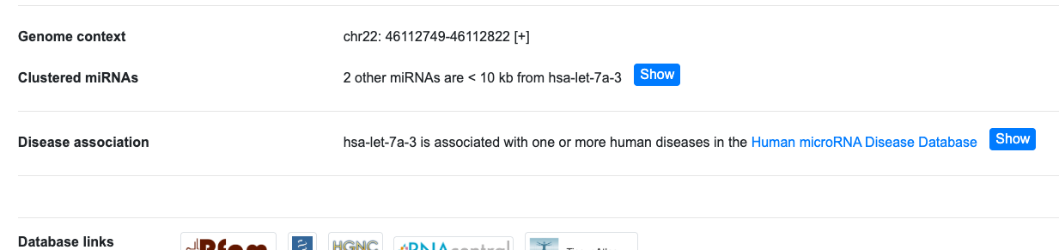
- Look at other bioinformatics papers to see what downstream software they use for DE analysis
  - MiRDeep2 https://pmc.ncbi.nlm.nih.gov/articles/PMC3245920/
- See bioinformatics section of the methods. This paper is from tamiRNA analysis of their propriety miRNA workflow https://www.mdpi.com/1422-0067/23/3/1226
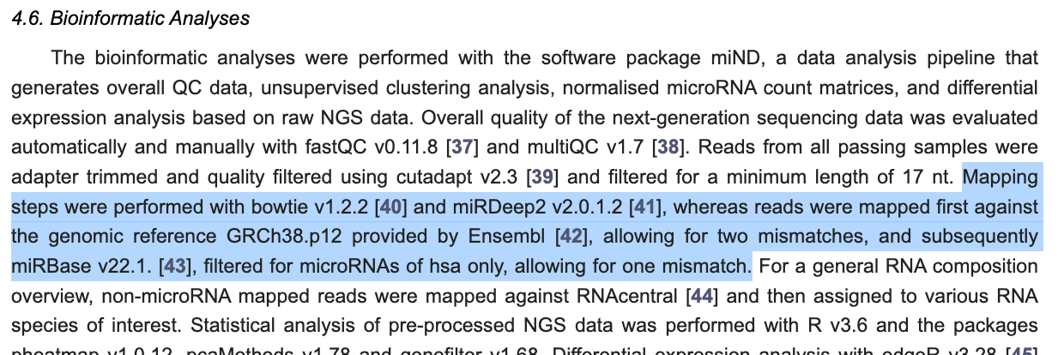

PART 2 – PATHWAY ENRICHMENT
- Got some good training videos for pathway enrichment anlysis etc. https://bioinformatics.ccr.cancer.gov/btep/btep-video-archive-of-past-classes/
- GSEA (gene set enrichment analysis) https://bioinformatics.ccr.cancer.gov/docs/btep-coding-club/CC2025/GSEA/GSEA/
- Pathway enrichment packages in r
  - clusterProfiler
  - ReactomePA
  - enrichplot
  - fgsea
- Pathway analysis software used in one of the 3 initial references supplied https://digitalinsights.qiagen.com/products-overview/discovery-insights-portfolio/analysis-and-visualization/qiagen-ipa/
- ToppGene was used for functional enrichment analysis of the miRNA targets (51) with a Bonferroni FDR <0.05. Biological process gene ontology (GO) terms generated through ToppGene were then summarised, and REViGO (52) and Cytoscape (53) were used to visualise the network. https://www.frontiersin.org/journals/veterinary-science/articles/10.3389/fvets.2022.901269/full?field=&id=901269&journalName=Frontiers_in_Veterinary_Science

Data Observations
- Number of miRNAs identified in raw data miRNA tables:
- Project 1 = 610
- Project 2 = 322
- miRNA nomenclature:
  - hsa-let-7a-3p
    - has = homo sapiens
    - let-7 = microRNA family
    - a = specific subtype
    - 3p = 3 prime
- Read counts are normalized to 1 million mapped miRNAs (RPM) to account for differences in sequencing depths between samples
    - RPM = reads for specific miRNA / total reads in sample * 1,000,000
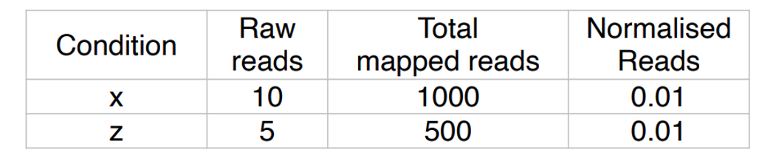 from transcriptomics lecture
N.B. RPM (aka counts per million) is not compatible with DE analysis. DGEA expects raw counts:
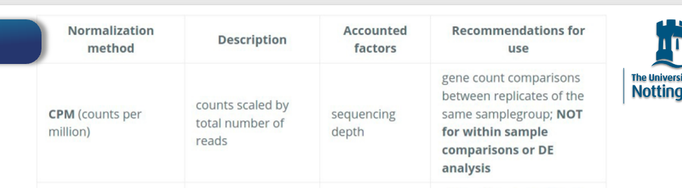 from transcriptomics lecture

